Static SW design

* **For ECU1 :**

1. DIO :

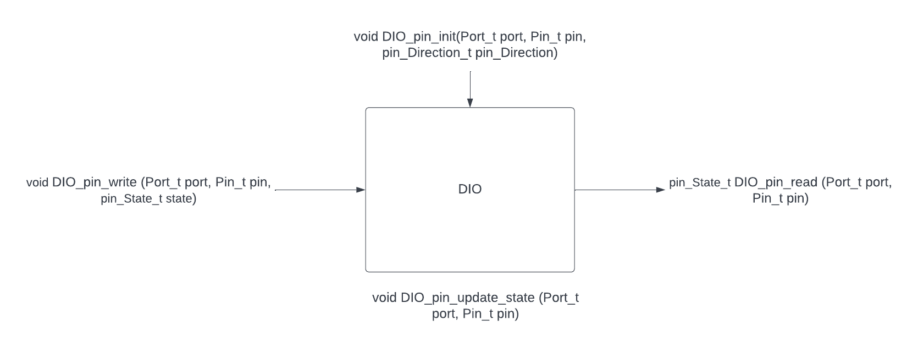

|  |  |  |  |  |  |  |  |
| --- | --- | --- | --- | --- | --- | --- | --- |
| API | Reentrant  Or  Non-Reentrant | | Sync  Or  Async | | Recursion  Or  Non-Recursion | | Type |
| Void DIO_pin_init | Reentrant | | sync | | Non-Recursion | | Function |
| Description | Function responsible for initialize given pin configurations | | | | | | |
| Args | 1. Port_t port : port which has pin to be configured 2. Pin_t pin : pin to be configured 3. pin_Direction_t pin_direction : the direction of the pin to be configured | | | | | | |
| Return | None | | | | | | |
| Void DIO_pin_write | Reentrant | sync | | Non-Recursion | | MACRO | |
| Description | Function responsible for write a value on given pin | | | | | | |
| Args | 1. Port_t port : port which has pin to output on 2. Pin_t pin : pin to write on 3. pin_State_t state : value to be written | | | | | | |
| Return | None | | | | | | |
| API | Reentrant  Or  Non-Reentrant | | Sync  Or  Async | | Recursion  Or  Non-Recursion | | Type |
| Void DIO_pin_read | Reentrant | | sync | | Non-Recursion | | MACRO |
| Description | Function responsible for read a value from a given pin | | | | | | |
| Args | 1. Port_t port : port which has pin to be read 2. Pin_t pin : pin to be read | | | | | | |
| Return | pin_State_t state : value to be read | | | | | | |
| Void DIO_pin_update_state | Reentrant | sync | | Non-Recursion | | Function | |
| Description | Function responsible for updating value on given pin | | | | | | |
| Args | 1. Port_t port : port which has pin to output on 2. Pin_t pin : pin to write on | | | | | | |
| Return | None | | | | | | |

1. door_Sensor_D: 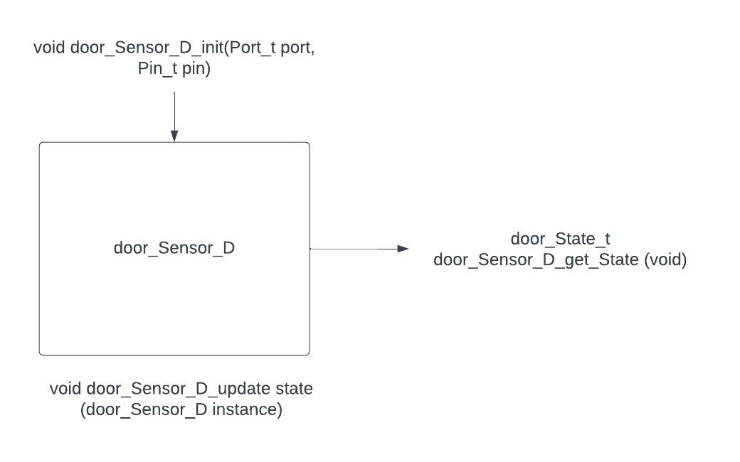

|  |  |  |  |  |
| --- | --- | --- | --- | --- |
| API | Reentrant  Or  Non-Reentrant | Sync  Or  Async | Recursion  Or  Non-Recursion | Type |
| Void door_Sensor_D_init | Reentrant | sync | Non-Recursion | Function |
| Description | Function responsible for initialize door sensor configurations | | | |
| Args | 1. Port_t port : port which has pin connected to the sensor 2. Pin_t pin : pin connected to the sensor | | | |
| Return | None | | | |
| door_State_t door_Sensor_D_get_State | Reentrant | sync | Non-Recursion | MACRO |
| Description | Function responsible for getting sensor value | | | |
| Args | None | | | |
| Return | door_State_t sensor_State : return the door state | | | |
| void door_Sensor_D_update_state | Non-Reentrant | sync | Non-Recursion | Function |
| Description | Function responsible for updating value on sensor | | | |
| Args | door_Sensor_D instance : instance of sensor model | | | |
| Return | None | | | |

1. 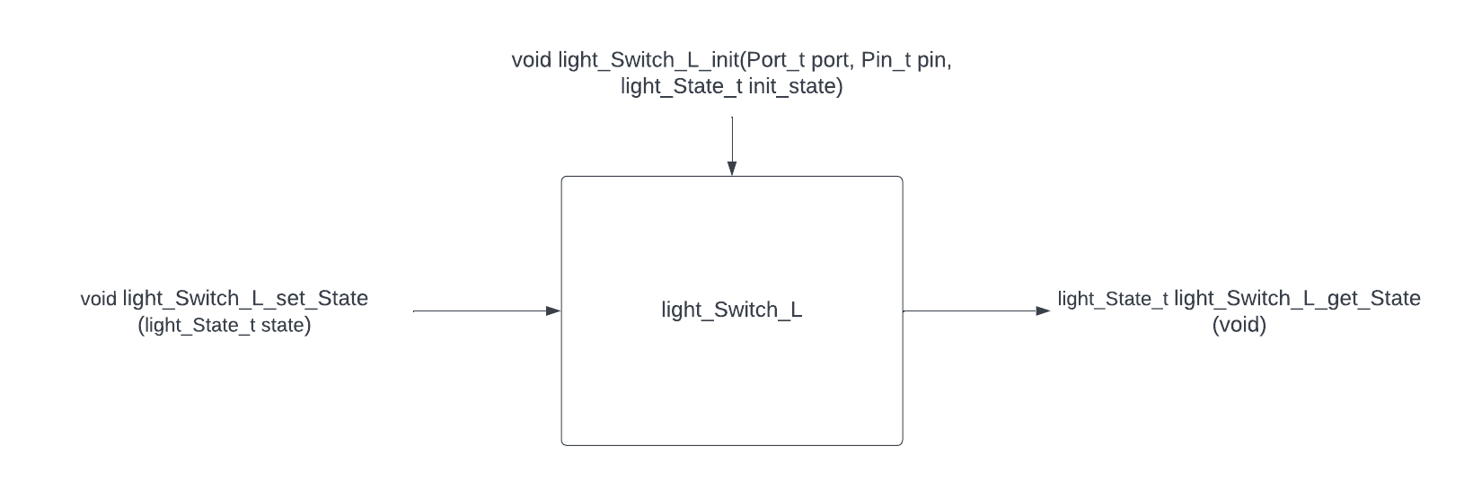light_Switch_L:

|  |  |  |  |  |
| --- | --- | --- | --- | --- |
| API | Reentrant  Or  Non-Reentrant | Sync  Or  Async | Recursion  Or  Non-Recursion | Type |
| Void light_Switch_L_init | Reentrant | sync | Non-Recursion | Function |
| Description | Function responsible for initialize light switch configurations | | | |
| Args | 1. Port_t port : port which has pin connected to the light switch 2. Pin_t pin : pin connected to the light switch 3. light_State_t init_state : initial state of light switch | | | |
| Return | None | | | |
| light_State_t light_Switch_L_get_State () | Reentrant | sync | Non-Recursion | MACRO |
| Description | Function responsible for getting light switch value | | | |
| Args | None | | | |
| Return | light_State_t light_State : return the light switch state | | | |
| void light_Switch_L_set_State | Reentrant | sync | Non-Recursion | MACRO |
| Description | Function responsible for setting light switch state | | | |
| Args | light_State_t state : the light switch state to be set | | | |
| Return | None | | | |

1. speed_Sensor_S:

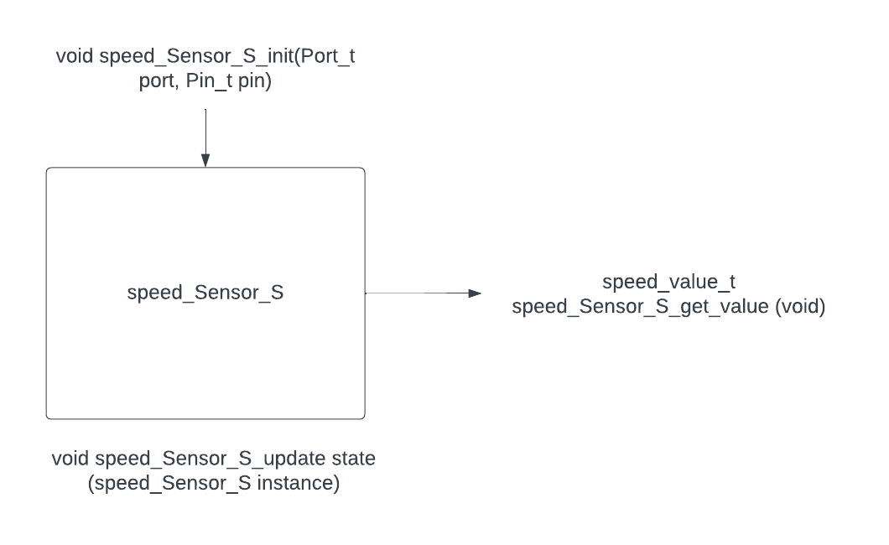

|  |  |  |  |  |
| --- | --- | --- | --- | --- |
| API | Reentrant  Or  Non-Reentrant | Sync  Or  Async | Recursion  Or  Non-Recursion | Type |
| void speed_Sensor_S_init | Reentrant | sync | Non-Recursion | Function |
| Description | Function responsible for initialize speed sensor configurations | | | |
| Args | 1. Port_t port : port which has pin connected to the sensor 2. Pin_t pin : pin connected to the sensor | | | |
| Return | None | | | |
| speed_value_t speed_Sensor_S_get_value | Reentrant | sync | Non-Recursion | MACRO |
| Description | Function responsible for getting sensor value | | | |
| Args | None | | | |
| Return | speed_value_t sensor_Value: return the speed value | | | |
| void speed_Sensor_S_update state | Non-Reentrant | sync | Non-Recursion | Function |
| Description | Function responsible for updating value on sensor | | | |
| Args | speed_Sensor_S instance : instance of sensor model | | | |
| Return | None | | | |

1. CAN:

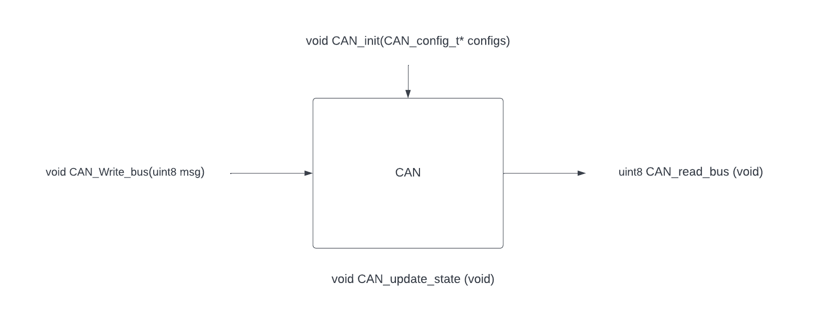

|  |  |  |  |  |
| --- | --- | --- | --- | --- |
| API | Reentrant  Or  Non-Reentrant | Sync  Or  Async | Recursion  Or  Non-Recursion | Type |
| void CAN_init | Reentrant | sync | Non-Recursion | Function |
| Description | Function responsible for initialize CAN configurations | | | |
| Args | 1. CAN_config_t* configs : pointer to configurations of CAN | | | |
| Return | None | | | |
| void CAN_Write_bus | Reentrant | sync | Non-Recursion | MACRO |
| Description | Function responsible for send message on the CAN bus | | | |
| Args | uint8 msg : message to be sent. | | | |
| Return | None | | | |

|  |  |  |  |  |
| --- | --- | --- | --- | --- |
| API | Reentrant  Or  Non-Reentrant | Sync  Or  Async | Recursion  Or  Non-Recursion | Type |
| uint8 CAN_read_bus | Reentrant | sync | Non-Recursion | MACRO |
| Description | Function responsible for receiving message from CAN bus | | | |
| Args | None | | | |
| Return | uint8 received_Msg : message to be received. | | | |
| void CAN_update_state | Non-Reentrant | sync | Non-Recursion | Function |
| Description | Function responsible for updating CAN bus value | | | |
| Args | None | | | |
| Return | None | | | |